A Study on Pseudo Stereoscopic Vision from a Piece of Human Group Picture
Face Recognition, Segmentation, and Depth Estimation

Makoto Takamatsu, Ayaka Nakamura,
Seiji Ishihara, Makoto Hasegawa
Tokyo Denki University
Tokyo, Japan
16ec068@ms.dendai.ac.jp, a_nakamura@m.ieice,
hasegawa@mail.dendai.ac.jp, ishihara_s@mail.dendai.ac.jp
Eizaburo Iwata
Universal Robot Co., Ltd.
Tokyo, Japan
eiza@urobot.co.jp

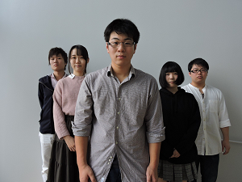
(a)
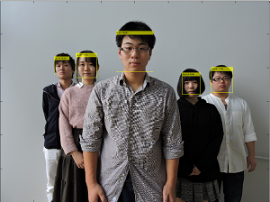
(b)
Fig.1 (a) Original image, (b) face recognition

Abstract— a method of pseudo stereoscopic vision from a piece of human picture is proposed. Faces from a group photo are detected using face recognition systems, and the distance from camera lens called ``depth” of each person is estimated using each face size. We propose a method of segmenting each person using superpixels. To generate our pseudo stereoscopic vision, we create two images for right-eye and left-eye as each region of the person is moved according to its depth, and convert to an anaglyph image. In this paper, we describe our method and show the pseudo stereoscopic results.
Keywords— pseudo stereoscopic vision; face recognition; depth estimation; segmentation; anaglyph

Introduction
Developing several three-dimensional capture devices as the RGB-D camera and the light field camera, demand of stereoscopic vision is increasing recently; however such devices are relatively expensive and not popular in our daily life. On the other hand, various methods for stereoscopic vision using many pictures are proposed, and it is possible to generate a stereoscopic image using a normal digital camera. Since those methods cannot perform using only one picture, it is impossible to realize the stereoscopic vision by a still image taken in the past. Therefore, we have also proposed a method to realize the stereoscopic vision using only one picture. Objects appearing on the picture are segmented, and we compute the convex hull of each object regions; our stereoscopic vision is generated considering object foreground or background with the overlap between the convex hull and the area [1]. Our pervious method can estimate the foreground or background of objects, however we have to assign the distance between the objects manually.
In this paper, we propose a novel method using a face recognition system, and the distance from camera lens called ``depth” of each person is estimated using each face size. Each person in the picture is clipped out by segmentation; each region of the person is moved according to its depth, and we create two images for right-eye and left-eye. Finally, to generate our pseudo stereoscopic vision, we convert two images for right-eye and left-eye to an anaglyph image.

Face recognition and stereoscopic image generation
We recognize faces from a group photo and then measure each person’s face. Faces in an original picture shown in Fig. 1(a) are detected using a face recognition system; Fig. 1(b) indicates the result of face recognition. Faces are described using square bounding boxes in the result. The face size is assumed as the length of one side on the square. The forward person’s face size is large, and the behind person’s one is getting small.

Segmentation
Person in a picture is clipped out by segmentation using superpixels [3, 4]. Those superpixels adhere well to the natural region boundaries, and each superpixels do not overlap with multiple objects. Fig. 2(a) indicates the result of superpixels. Then, we integrated superpixels manually as Fig. 2(b).

Stereoscopic Image Generation
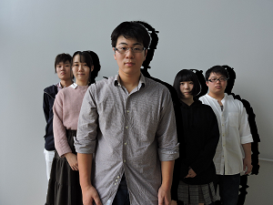
(a)
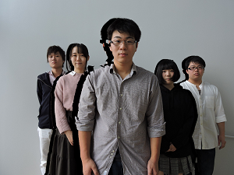
(b)
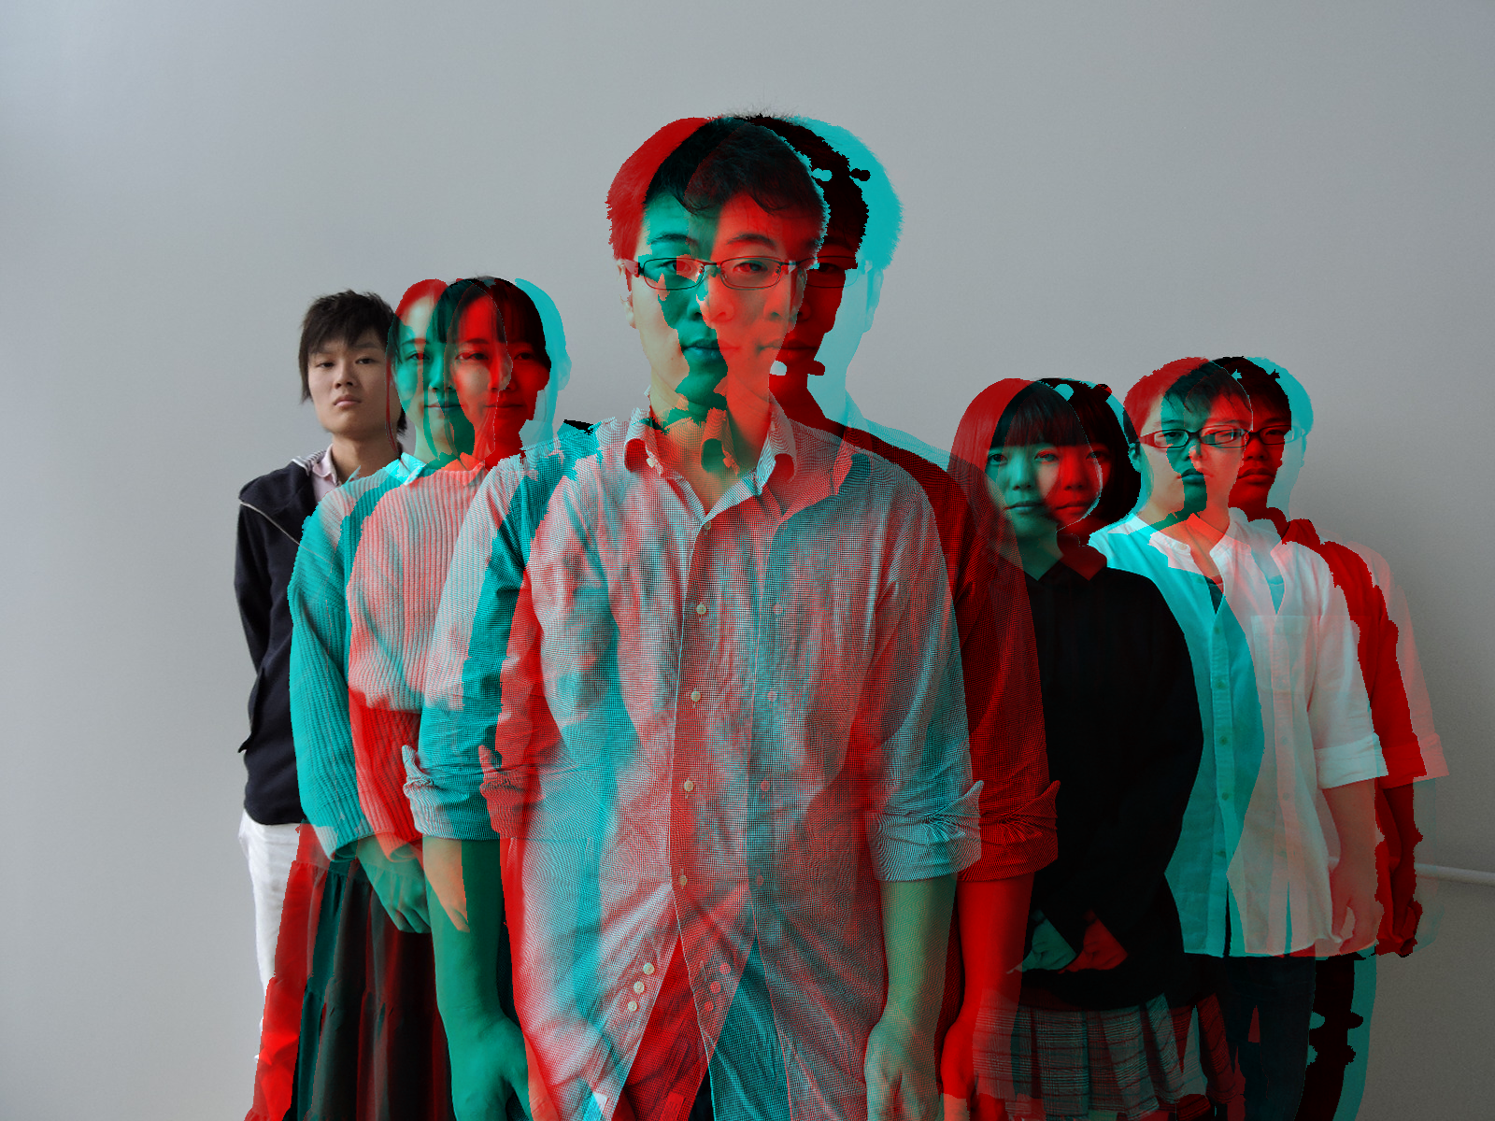
(c)
Fig.3 (a) Right-eye image, (b) left-eye image, (c) stereoscopic image using anaglyph.

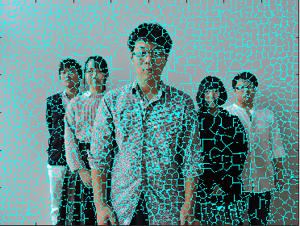
(a)
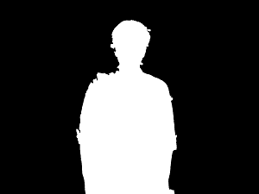
(b)
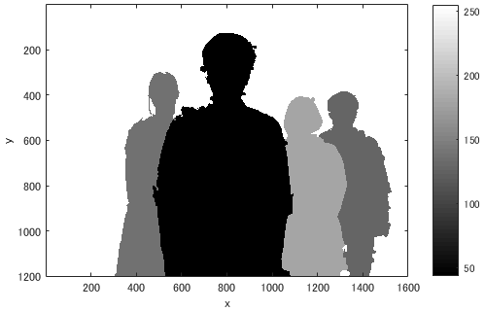
(c)
Fig. 2 (a) Superpixels ,(b) segmentation,(c) depth image.

Depth of person is defined as,
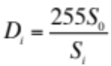 (1)
where is the size of the most behind person face, and is the size of each person’s face. The depth takes a value from 0 to 255. The depth of most behind person is 255. Actually, each face size is different, however in this paper we presume all face size are equal for our depth computation. The result of depth image is shown in Fig2. (c).
We create two images for right-eye and left-eye as each region of the person is translated left and right according to the depth. Movement amount of person is defined as,
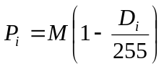 [Pixel] (2)
where is the adjusting value, and we have to configure it. The results of images for right-eye and left-eye are shown in Fig. 3(a) and 3(b). We convert the two images to an anaglyph image as Fig. 3(c). Our pseudo stereoscopic vision is realized by wearing an anaglyph red-blue glasses.

References
- Eisaku Higuchi, Eizaburo Iwata, and Makoto Hasegawa, “A Study of Stereoscopic Vision Based on Background and Foreground Estimation from a Single Image,” The Institute of Image Information and Television Engineers, 24B-1, Dec. 2016.
- Makoto Takamatsu,Ayaka Nakamura,Eizaburo Iwata,Makoto Hasegawa:”Pseudo-stereoscopic viewing by object size estimation using object recognition system”,The 2017 IEICE General Conference,ISS student poster session, 2017.
- Xiaofeng Ren,Jitendra Malik,”Learning a Classification Model for Segmentation,”9th IEEE International Conference on Computer Vision, Oct. 2003.
[4] Zhengqin Li,Jiansheng Chen,”Superpixel Segmentation using Linear Spectral Clustering,”IEEE Conference on Computer Vision and Pattern Recognition, Jun. 2015.

